CSCE-608 Database Systems
Spring 2026
Project 1
(Due March 20)
Part A. E/R Diagram
The goal of this project is to develop a database application for an Airline Management System. This system is designed to manage the core operational data of a commercial airline, including the scheduling of flights, management of aircraft fleets, and the processing of passenger reservations.
The application will provide a centralized platform to handle:
Flight Scheduling: Tracking flight routes, including departure and arrival airports and scheduled times.
Fleet Management: Maintaining records of individual aircraft, their models, and total passenger capacity.
Employee Assignment: Assigning pilots and crew members to specific flights based on their rank and employee status.
Reservation Booking: Facilitating the booking process where passengers are linked to specific flights and assigned seat numbers.
A complex aspect of this application is to ensure data integrity regarding seating capacity. In a real-life scenario, flights are often overbooked but to reduce complexity of the application, the system must prevent overbooking by ensuring the number of records in the Booking relation does not exceed the Capacity defined in the Aircraft relation for a specific flight. Additionally, managing the many-to-many relationship between crew members and flights requires handling of scheduling conflicts.
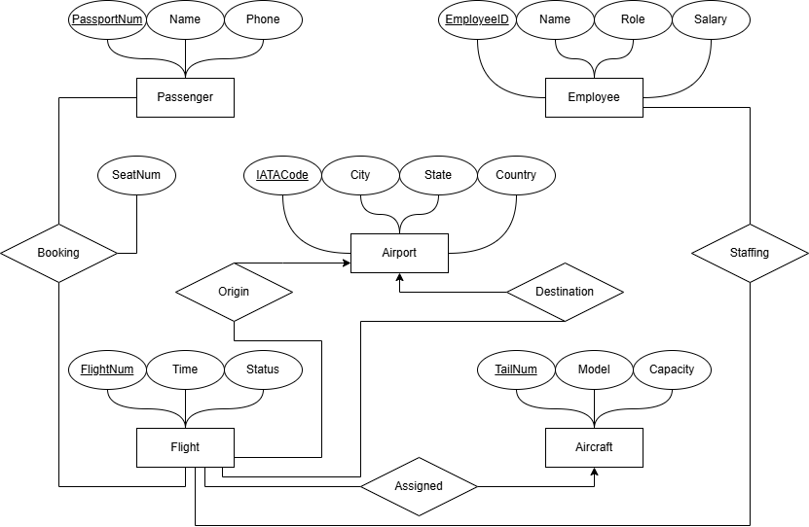
Part B. Relational Schema
- The following are a set of relations that can be formed from the E/R diagram:
  - Passenger(PassportNum, Name, Phone)
  - Employee(EmployeeID, Name, Role, Salary)
  - Airport(IATACode, City, State, Country)
  - Aircraft(TailNum, Model, Capacity)
  - Flight(FlightNum, Time, Status, TailNum, OriginCode, DestCode)
  - Booking(PassportNum, FlightNum, SeatNum)
  - Staffing(EmployeeID, FlightNum)
- The nontrivial functional dependencies are as follows:
  - PassportNum → Name, Phone
  - EmployeeID → Name, Role, Salary
  - IATACode → City, State, Country
  - TailNum → Model, Capacity
  - FlightNum → Time, Status, TailNum, OriginCode, DestCode
  - PassportNum, FlightNum → SeatNum
- To determine if the database schema is in Boyce-Codd Normal Form (BCNF), we must evaluate each relation to ensure that for every non-trivial functional dependency X → Y, the determinant X is a superkey.
  - PassportNum → Name, Phone: Not a violation since PassportNum is the primary key, it is the superkey.
  - EmployeeID → Name, Role, Salary: Not a violation since EmployeeID is the primary key, it is the superkey.
  - IATACode → City, State, Country: Not a violation since IATACode is the primary key, it is the superkey.
  - TailNum → Model, Capacity: Not a violation since TailNum is the primary key, it is the superkey.
  - FlightNum → Time, Status, TailNum, OriginCode, DestCode: Not a violation since FlightNum is the primary key, it is the superkey.
  - PassportNum, FlightNum → SeatNum: Not a violation since the composite attribute (PassportNum, FlightNum) is the primary key, it is the superkey.
  - Discussion and Results:
During the relation normalization process, all FDs derived from the E/R diagram already satisfy BCNF. As a result, there is no need for relations to be decomposed into smaller relations, and no new relations were produced. The relations pass the BCNF test because every determinant in the schema is a candidate key because of which, the relations have no redundancies or update anomalies. For example, if an airport's city or country changes, that data only exists in the Airport table. The Flight table safely references the airport via the IATACode foreign keys (OriginCode and DestCode) without duplicating the geographical data, ensuring data integrity across the database.

